DIGITAL DESIGN COEN 312 Lecturers: A. J. Al-Khalili, S. Jahinuzzaman
Answer All Questions. Time Allowed 1 hr. 10min. Midterm exam. Oct 15th, 2009
Sample A
Question 1 (Use Boolean Algebra for Question 1)
1.a Simplify to obtain minimum SOP (2 marks)
F(A, B, C, D) = ACD’+ABC’+BC’D+ABC+A’CD’+BCD’
1.b Simplify to obtain minimum SOP (2 marks)
F(A, B, C, D) = A’B’(1 +C’) + A + (1 . D’)D
1.c Minimize the following circuit, Give minimum circuit in NAND-NAND Form.
(3 marks)
Question2
a) Give minimal SOP for F(a,b,c,d) given by the following K-map (2 marks)
Identify the prime Implicants clearly. Give an AND-OR-NOT implementation.
cd
ab
00

01

11

10
00 01 11 10
X X X X

1 1 X

1

X 1 1 X

b) Give minimal NOR-NOR implementation for F(a,b,c,d) given by the following K-map (2 marks).
cd
ab
00

01

11

10
00 01 11 10
X X

X

X

X 1 1 X

Question 3
b
F1
F
F2
In the circuit below:
Delay of inverter =4ns
Delay of AND =8ns
Delay of OR =10ns
Input of the circuit goes from ab= 00 to 01 draw timing diagram for the circuit. (4 marks)
a

Solution

Question1
1.a.
$$\begin{aligned}F=\text{AC}\overline{D}+\text{AB}\overline{C}+B\overline{C}D+\text{ABC}+\overline{A}C\overline{D}+\text{BC}\overline{D} \\ F=C\overline{D}(A+\overline{A})+\text{AB}(C+\overline{C})+B\overline{C}D+\text{BC}\overline{D} \\ F=C\overline{D}+\text{AB}+B\overline{C}D+\text{BC}\overline{D} \\ F=C\overline{D}+\text{AB}+B\overline{C}D\end{aligned}$$

1.b.
$$\begin{aligned}F=\overline{A}\overline{B}(1+\overline{C})+A+(1\text{.}D)(\overline{D}) \\ F=\overline{A}\overline{B}(1)+A+0 \\ F=A+\overline{B}\end{aligned}$$


1.c.
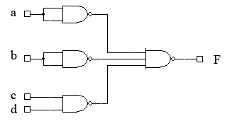
$$\begin{aligned}F=\overline{(\overline{a⊕b})\text{.}(\overline{c\text{.}d})}+a \\ F=(a⊕b)+(c\text{.}d)+a \\ F=a\overline{b}+\overline{a}b+\text{cd}+a \\ F=a+\overline{a}b+\text{cd} \\ F=a+b+\text{cd}\end{aligned}$$

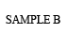
1.c.
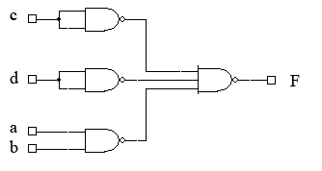
$$\begin{aligned}F=\overline{(\overline{c⊕d})\text{.}(\overline{a\text{.}b})}+c \\ F=(c⊕d)+(a\text{.}b)+c \\ F=c\overline{d}+\overline{c}d+\text{ab}+c \\ F=c+\overline{c}d+\text{ab} \\ F=c+d+\text{ab}\end{aligned}$$

Question 2

Q2. a  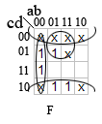  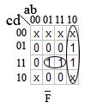  $$\begin{aligned}F=\overline{a}\overline{b}+\overline{a}\overline{c}+\overline{d} \\ {\text{PI}}_{1}=\sum{m(4,5,\text{12},\text{13})=b\overline{c}} \\ {\text{PI}}_{2}=\sum{m(0,1,2,4,5)=\overline{a}\overline{c}} \\ {\text{PI}}_{3}=\sum{m(0,1,2,3)=\overline{a}b} \\ {\text{PI}}_{4}=\sum{m(0,2,4,6,8,\text{10},\text{12},\text{14})=\overline{d}}\end{aligned}$$  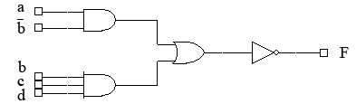  $$\begin{aligned}F=a\overline{b}+\text{bcd} \\ F=a\overline{b}+\text{bcd}\end{aligned}$$  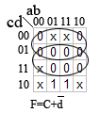  b)  POS $F=c\overline{d}$  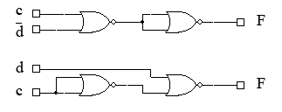  $$\text{SOP}=c\overline{d}$$ | 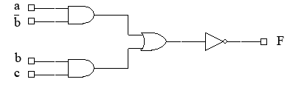  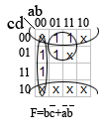  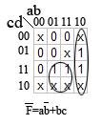  $$\begin{aligned}{\text{PI}}_{1}=\sum{m(4,5,\text{12},\text{13})} \\ {\text{PI}}_{2}=\sum{m(0,1,2,4,5)}\end{aligned}$$  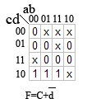  $$F=c\overline{d}$$
Question 3.
