Department of Electrical and Computer Engineering
COEN 312 Oct. 16, 2008
Answer all Questions.
Exam Duration 1 hour
No books or papers are allowed. Examiner: Asim J. Al-Khalili

===============================================================

Question 1

Using Boolean algebra, minimize the following functions:
a) F1 (A,B,C,D) = ABCD + (A’BD)’ + ABC’D 3 Marks
b) F2 (A,B,C,D) = AB (D + C’D ) + B ( A + A’CD) 3 Marks

Question 2
Given f(x,y,z) = xy +x z’ + yz

a) Implement f in NOR-NOR format 3 Marks

b) Implement f in AND-OR-INVERT format 3 Marks
Obtain optimum implementation.

Question 3

Implement the following four Boolean expressions with three Half Adders:
F1(A,B,C) = $A⊕B⊕C$ 1 Mark
F2( A,B,C) = A’BC + AB’C 1 Marks
F3 (A,B,C) = ABC’ + ( A’ + B ‘ ) C 4 Marks
F4 (A,B,C) = ABC 1 Mark

Question 4

- Simplify the function F Using K-Map. Express the simplified function in SOP and POS
F(A,B,C,D) = Σ m(1,3,8,10,15) + d Σ m(0,2,9) 3 Marks

- For Function F below, find all the Prime Implicants and determine which ones are essential:
F(A,B,C,D) = Σ m( 1,3,6,7,8,9,12,13,14,15) 3 Marks
SOLUTION

COEN312, OCT16 2008
Q1.

$$\begin{aligned}F1(A,B,C,D)=\text{ABCD}+(A'\text{BD})'+\text{ABC}'D \\ =\text{ABCD}+A+B'+D'+\text{ABC}'D \\ =A+B'+D'\end{aligned}$$

$$\begin{aligned}F1(A,B,C,D)=\text{AB}(D+C'D)+B(A+A'\text{CD}) \\ =\text{ABD}+B(A+\text{CD}) \\ =\text{ABD}+\text{AB}+\text{BCD} \\ =\text{AB}+\text{BCD}\end{aligned}$$

Q2.

a)

$$\begin{aligned}f(x,y,z)=\text{xy}+\text{xz}'+\text{yz} \\ =\text{xz}'+\text{yz}\end{aligned}$$

f in NOR-NOR format:
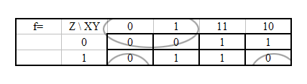
K-Map representation:

$$f(x,y,z)=(x+z)⋅(y+z')$$
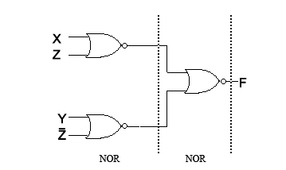

Also, using Boolean minimization,

$$\begin{aligned}f(x,y,z)=\text{xz}'+\text{yz} \\ f=\overline{\overline{(x+z)\text{.}(y+z')}} \\ f=\overline{\overline{(x+z)}+\overline{(y+z')}}\end{aligned}$$

b)

  f= | Z \ XY | 00 | 01 | 11 | 10
   | 0 | 0 | 0 | 1 | 1
   | 1 | 0 | 1 | 1 | 0
  f '= | Z \ XY | 00 | 01 | 11 | 10
   | 0 | 1 | 1 | 0 | 0
   | 1 | 1 | 0 | 0 | 1
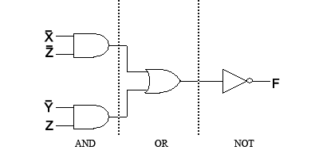
$$f'(x,y,z)=\overline{x}\overline{z}+\overline{y}z$$
Q3.
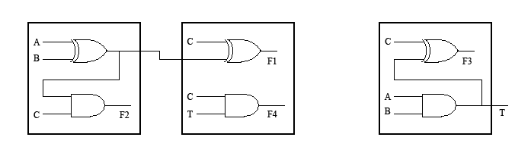

$F2=(A'B+\text{AB}')\text{.}C=(A⊕B)\text{.}C$

$$\begin{aligned}F3=\text{ABC}'+(A'+B')C \\ =\text{ABC}'+(\text{AB})'C \\ =(\text{AB})⊕C\end{aligned}$$

Q4.
a)
f= | CD\AB | 00 | 01 | 11 | 10
 | 00 | X | 0 | 0 | 1
 | 01 | 1 | 0 | 0 | X
 | 11 | 1 | 0 | 1 | 0
 | 10 | X | 0 | 0 | 1

$$\text{SOP}=\sum{m(0,1,2,3)+}\sum{m(0,2,8,\text{10})+\sum{m(\text{13})=}\overline{A}\overline{B}+\overline{B}\overline{D}+\text{ABCD}}$$
$$\begin{aligned}\text{POS}=\prod{M(4,5,\text{12},\text{13})}⋅\prod{M(4,6,\text{12},\text{14})}⋅\prod{M(4,5,6,7)}⋅\prod{M(9,\text{11})} \\ =(A+\overline{B})(\overline{B}+C)(\overline{B}+D)(\overline{A}+B+\overline{D})\end{aligned}$$

b)
$\sum{m(\text{12},\text{13},\text{14},\text{15})=\text{AB}}$=NE
f= | CD\AB | 00 | 01 | 11 | 10
 | 00 | 0 | 0 | 1 | 1
 | 01 | 1 | 0 | 1 | 1
 | 11 | 1 | 1 | 1 | 0
 | 10 | 0 | 1 | 1 | 0
$\sum{m(8,9,\text{12},\text{13})=A\overline{C}}$=E
$\sum{m(6,7,\text{14},\text{15})=\text{BC}}$=E
$\sum{m(1,3)=\overline{A}\overline{B}D}$=E, $\sum{m(3,7)=\overline{A}\text{CD}}$=NE

E=Essential Prime Implicant
NE= Non-Essential Prime Implicant

